ESERA
ICONS
 |  |  |  |  |  |  | 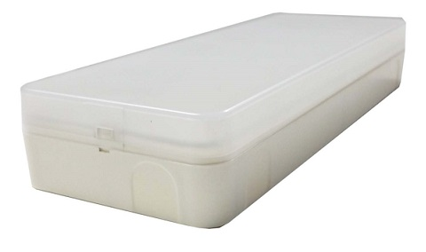 | 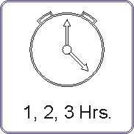
 |  |  |  |  |  |  |  | 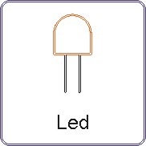
 |  |  |  |  |  |  |  | 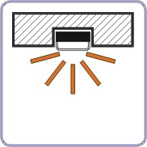
 |  |  |  |  |  |  |  | 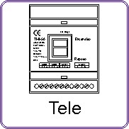
 |  |  |  |  |  |  | 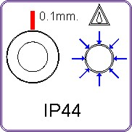 | 
 |  |  |  |  |  |  |  | 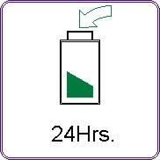
ESERA |  | 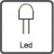 |  |  |  | 
60L | ES0600011L | LED | 80 | 1 | 44 | 1
100L | ES1000011L | LED | 110 | 1 | 44 | 1
150L | ES1500011L | LED | 140 | 1 | 44 | 1
200L | ES2000011L | LED | 190 | 1 | 44 | 1
300L | ES3000011L | LED | 320 | 1 | 44 | 1
400L | ES4000011L | LED | 430 | 1 | 44 | 1
500L | ES5000011L | LED | 500 | 1 | 44 | 1
ESERARED | ESERARED | LED | 300 | - | 44 | 1

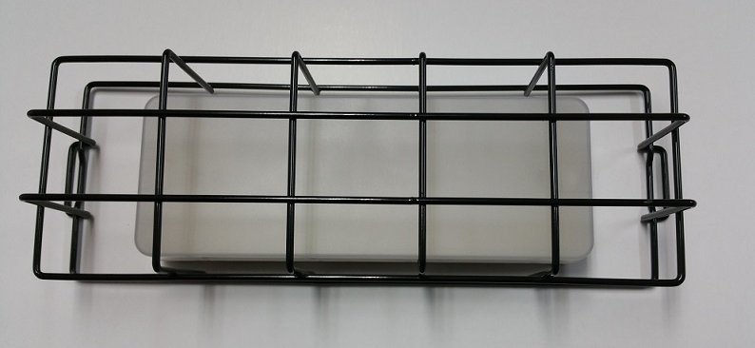
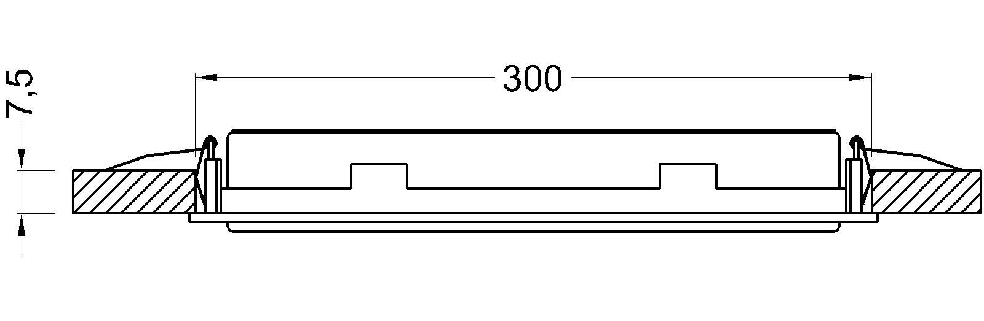
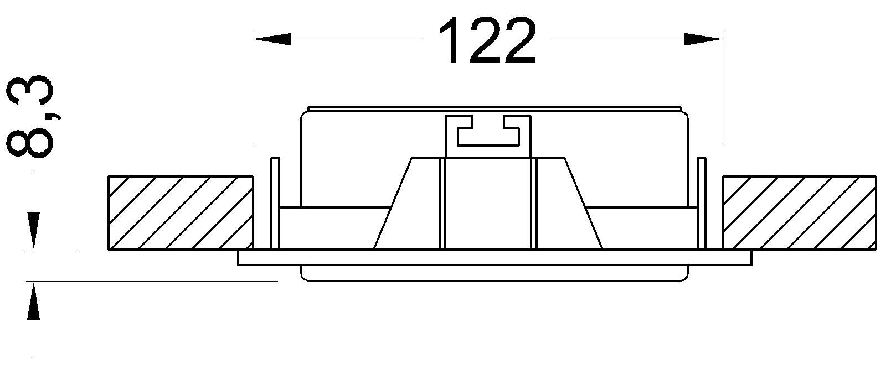
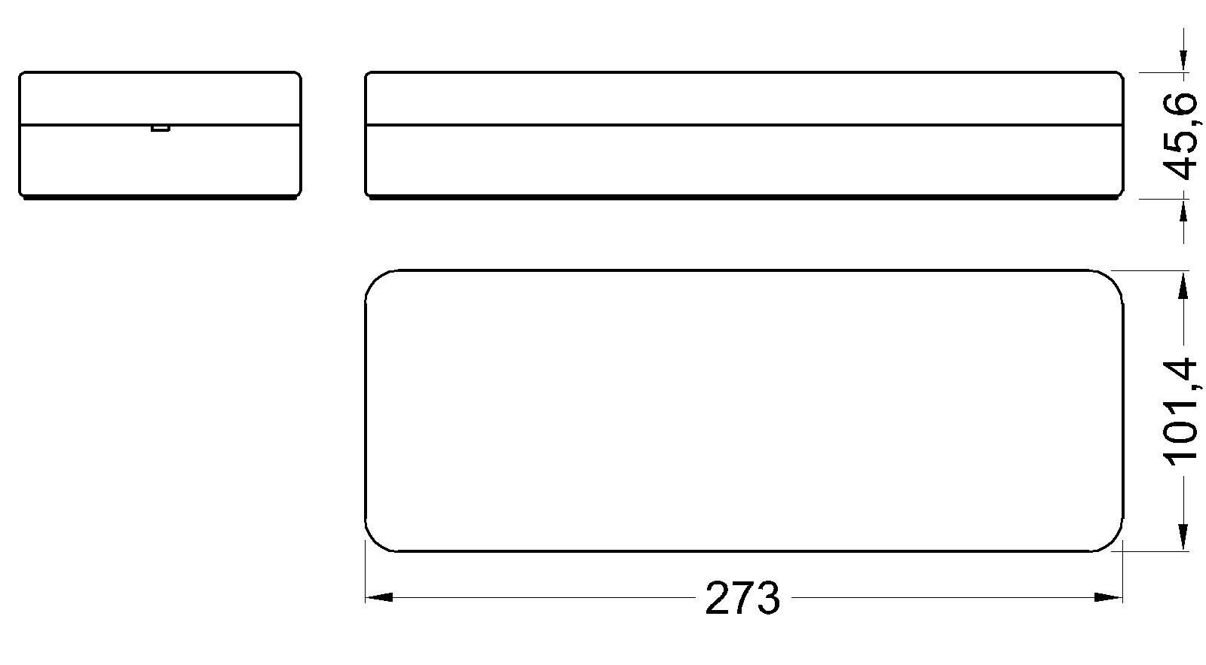
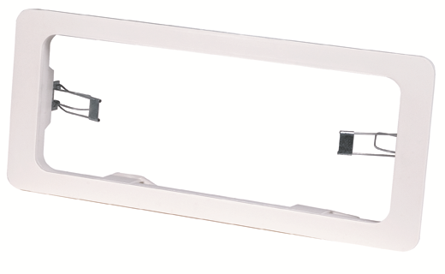
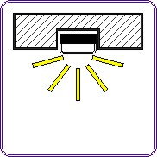

REF. REJA-BGA
Anti-vandal ochranná mřížka na svítidlo
Rozměry svítidla
Příslušenství
REF. AG100000
Sada pro montáž do podhledu

